SQL Assignment-1

**1: Write a query to get a Product list (id, name, unit price) where current products cost less than $20.**

**Query1:**

select ProductId, ProductName, UnitPrice from products as productList where Unitprice <20 and Discontinued=0;

**Output:**

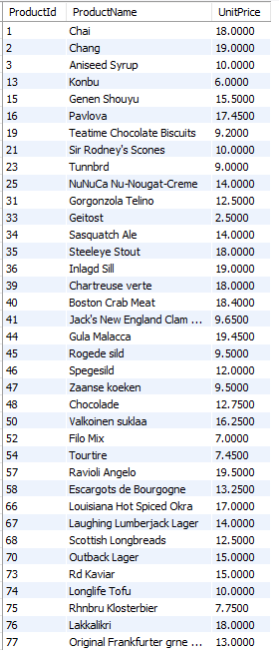

**2: Select ProductId, ProductName, UnitPrice from products as productList where Unitprice between 15 and 25;**

**Query2:**

select ProductId, ProductName, UnitPrice from products as productList where Unitprice between 15 and 25;

**Output:**

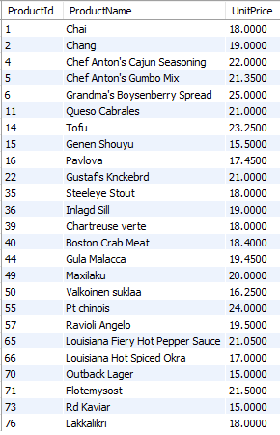

**3: Write a query to get a Product list (name, unit price) of above average price.**

**Query3:**

select ProductId, ProductName, UnitPrice from products as productList where Unitprice>(select avg(UnitPrice) from products);

**Output:**

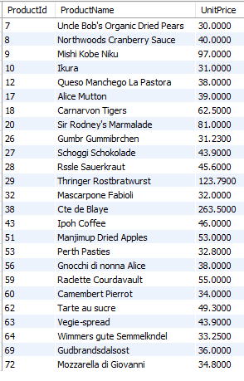

**4:Write a query to get Product list (name, unit price) of ten most expensive products**

**Query4:**

select ProductId, ProductName, UnitPrice from products as productList order by UnitPrice desc Limit 10 ;

**Output:**

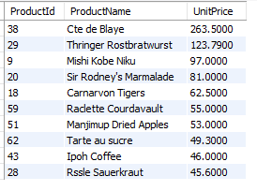

**5:Write a query to count current and discontinued products**

**Query5:**

select count(ProductId) as ProductStatus, Discontinued from products group by Discontinued;

**Output:**

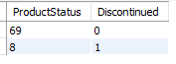

**6:Write a query to get Product list (name, units on order , units in stock) of stock is less**

**than the quantity on order**

**Query6:**

select ProductName, UnitsOnOrder, UnitsInStock from products as productList where UnitsInStock < UnitsOnOrder;

**Output:**

